Software Design Documentation
Submitted To | Mam Sara Farid
Submitted By | Aftab Hameed
Roll Number | F22BINFT1M01178

Blood Donor Finder

Department of Information Technology
Software Design Document (SDD)

The
Blood Donor Finder Mobile Application
Blood Donor

1. Introduction

This Software Design Document (SDD) presents the design and architecture for the Blood Donor Finder application created using Flutter. This application is designed to assist users to locate blood donors, to handle donor information, and to seek blood transfusions during an emergency.
1.2
The application supports: - Donor registration functionality for Android as well as iOS devices - Creating blood requests - Location-based searching for a donor near a user’s location - Real-time notifications for alerts such as blood donation requests amongst others - Secure user authentication

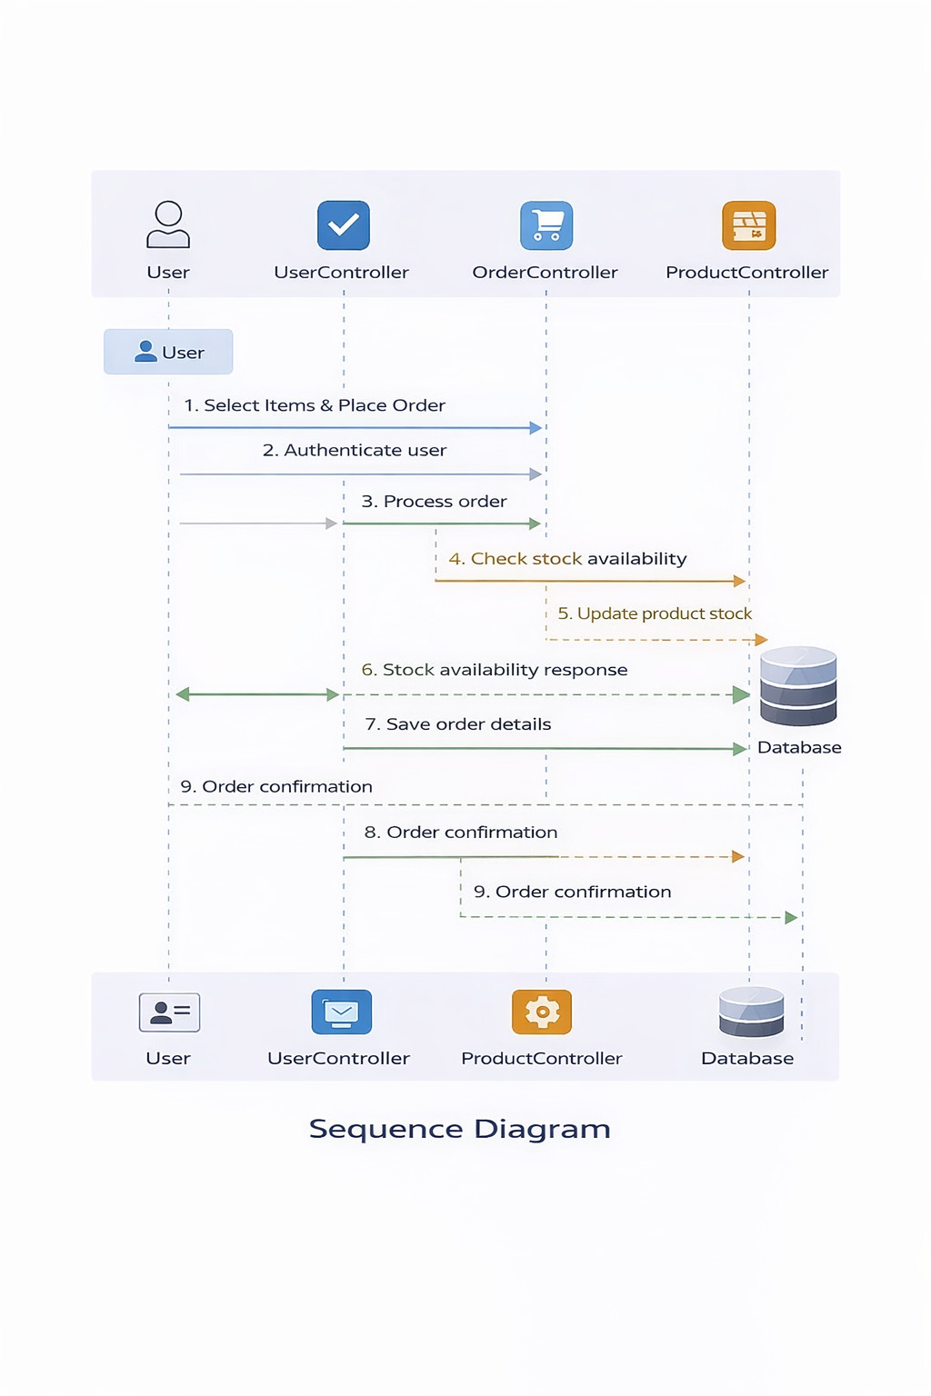

1.3 Intended

• Software developers
• Project supervisors
• QA Engineers
• Academic

2. Overall System Description
2.1 Product Perspective
The Blood Donor Finder is a client–server-based mobile application. Frontend: Flutter; backend, RESTful: Firebase handle authentication, database operations, and notifications.
2.2 User Classes
• Donor - They will register and make themselves available for the donation of their blood
• Recipient – Searches donors, creates blood requests
Admin: user management and activity tracking
2.3 Operating Environment
• MOBILE OS: Android 8+, iOS 13+
• Frontend: Flutter (Dart)
• Backend: Firebase / REST API
• Database: Firebase Firestore
• Maps: Google Maps API
The nervous system consists of the CNS, which includes the brain and spinal cord, and the PNS, which includes nerves.

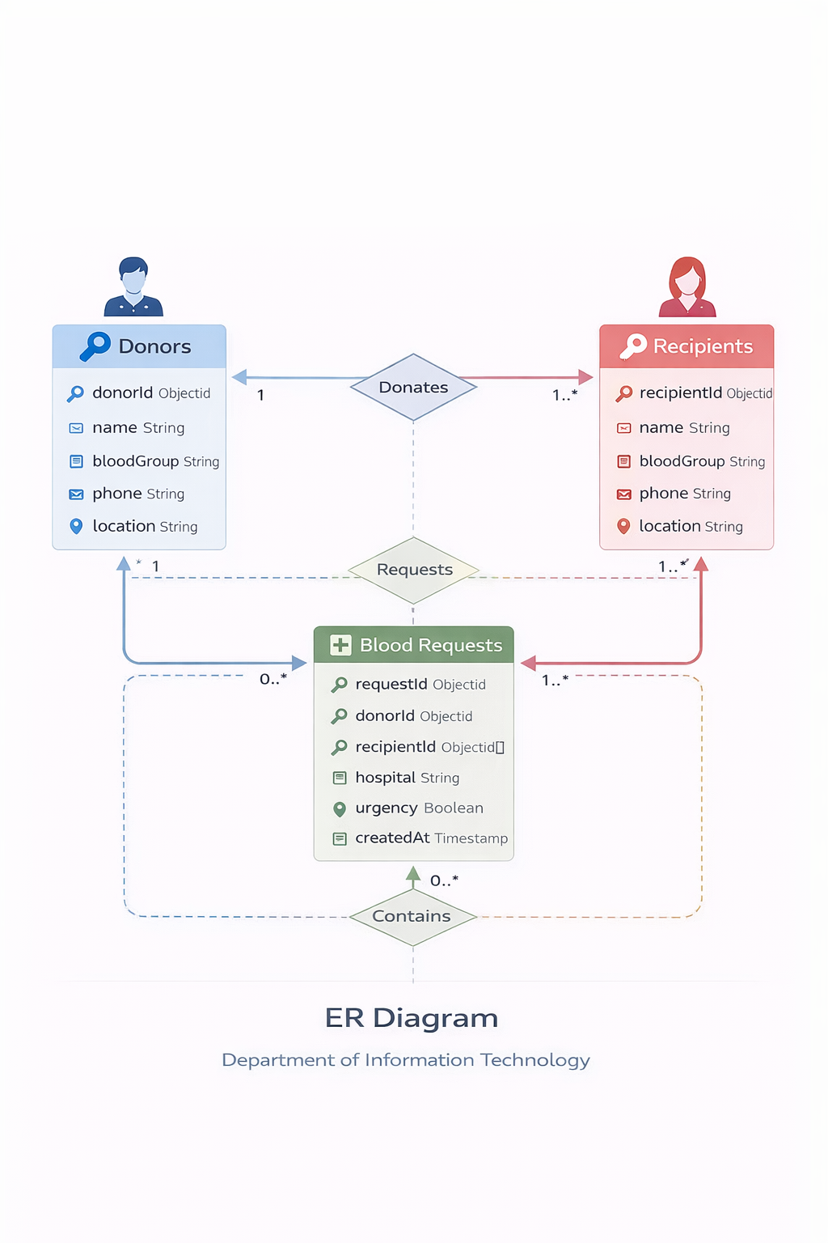

3. System Architecture

3.1 High-Level

Architectural Patterns: MVVM (Model

├── UI Layer ├── Flutter Screens (Views)

│

│ ViewModel │ Business Logic & State Management

│

│ Model Layer │ Data Models & Repositories

│

│ Backend/API │ Auth, Database, Notifications

3.2 Technology Stack

Layer

Frontend Flutter

Backend Firebase / REST API

Database Firebase FireStore

Authentication Auth Firebase

Notifications Firebase Cloud Messaging

_______________________________________

4. Module Design

4.1 Authentication Module

• User registration (Donor / Recipient)

• Login & Logout

• Phone / Email verification

4.2 Donor Management Module

• Donor profile creation

• Blood group selection

• Availability status

4.3 Blood Request Module
• Create blood request
• View active requests
• Accept or Reject Requests
4.4 Location & Search Module
• Locate local donors
• By blood group filter
• Distance-sort
4.5 Notification Module
• Emergency
• Ask for
• Push notifications

5. Data Design
5.1 USER TABLE
Field
User
name String
blood Group
phone String
location
role:
5.2 Blood Request Table:
Region
requestId:
bloodGroup
hospital
urgency < Boolean
createdAt

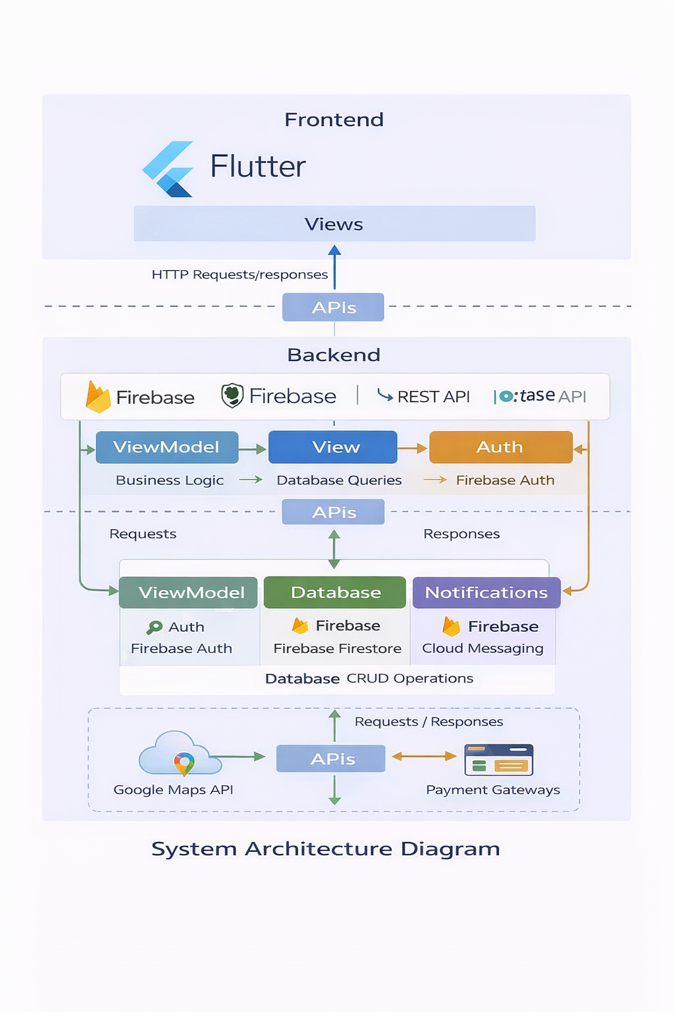

6. User Interface Design
6.1 Key Screens
• Splash Screen
• Login / Signup Screen
• Home Dashboard
• Donor Search Screen
• Blood Request Screen
• Profile Screen

7. Sample Application
7.1 Login Screen
Login Screen

Login Screen
7.2 Home Dashboard
Home Dashboard
7.3 Donor Search Screen
Donor Search
7.4 Blood Request Screen
Blood Request
Blood
RBC Transfusion

8. Non-Functional
• Managing secure data
• Fast search results
• User-friendly UI

9. Assumptions & Dependencies
• Internet connectivity is required
Provides:
• Availability of Google Maps
• Firebase services up

10. Conclusion
Blood Donor Finder Application will be developed in such a way that it will have a reliable, scalable, and user-friendly interface for the donors to connect with the recipients

